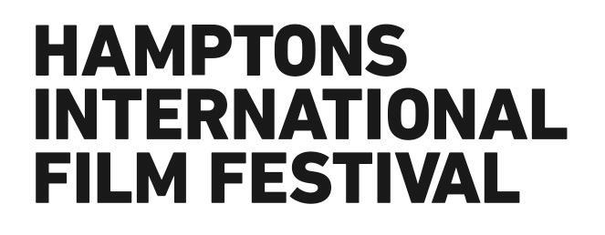

ALEC BALDWIN AND RANDY MASTRO NEWLY ELECTED AS
CO-CHAIRMEN OF THE HAMPTONS INTERNATIONAL FILM FESTIVAL

Stuart Match Suna To Step Down After 18 years

East Hampton, NY (August 3, 2015) – The Hamptons International Film Festival (HIFF) announced today that Alec Baldwin and Randy Mastro have been newly elected as Co-Chairmen of the Hamptons International Film Festival Board of Directors. Stuart Match Suna, a founder of the festival in 1992, will be stepping down from his Chairman position after 18 years, but will continue to support HIFF as Chair Emeritus.

“Stuart Match Suna has had a clear vision for HIFF ever since its inception, and I feel very privileged to have been part of such a passionate team,” said Alec Baldwin, newly elected Co-Chairman. “I’m thrilled to continue with the festival as we look to lay the ground for many more exciting years ahead.”

“This is an important and innovative festival that brings outstanding programs and events year round to the Hamptons,” said Randy Mastro, newly elected co-Chairman. “I’m honored to be serving with Alec and expand what Stuart Match Suna has already successfully done with HIFF.”

Baldwin and Mastro will serve as Co-Chairmen beginning after this year’s festival, which marks its 23rd year.

“Both Alec and Randy have been instrumental to the festival over the past decade, and I’m very pleased to see them taking on these positions,” said Stuart Match Suna. “I’m incredibly grateful for the past 18 years having served as Chairman and seeing the festival grow since its inauguration. It’s an honor to have such varied talents as Alec and Randy elected to lead HIFF.”

Alec Baldwin has been a HIFF board member for the past decade. He has been a longtime supporter of the festival, also producing its SummerDocs series for the past 7 years. Baldwin most recently starred in a revival of Arthur Miller’s classic drama, All My Sons, directed by Stephen Hamilton at Guild Hall in East Hampton. Baldwin starred with Tina Fey in the popular sitcom “30 Rock,” for which he received two Emmy awards and a record seven SAG awards as best actor in a comedy. He has appeared in over 50 films, including some recent Award-winners including Still Alice, Blue Jasmine, and The Departed.

Randy Mastro, who has been on HIFF’s board for the past 9 years, is a partner in the New York office of Gibson, Dunn & Crutcher, and Co-Chair of the Firm’s Litigation Practice Group. He routinely ranks among the nation’s leading litigators and trial lawyers in surveys of corporate counsel and other practitioners. Previously, Mastro served as Deputy Mayor of New York City as a federal prosecutor in the U.S. Attorney’s Office for the Southern District of New York. Mastro graduated cum laude from Yale College and the University of Pennsylvania Law School. He currently teaches as an adjunct professor at the University of Pennsylvania Law School, and previously taught as an adjunct professor at Fordham Law School.

The 23rd Annual Hamptons International Film Festival, which will be held over Columbus Day Weekend, October 8th – 12th, 2015, greatly appreciates the support from their corporate sponsors, including Delta Air Lines, Altour International, The Wall Street Journal, and WNBC New York. Founders Passes go on sale August 17th and other passes September 8th. Box office will open on September 26th in NYC, East Hampton and Southampton.

ABOUT THE HAMPTONS INTERNATIONAL FILM FESTIVAL
The Hamptons International Film Festival (HIFF) is a year-round 501(c)3 non-profit organization with events, screenings, film workshops, comprehensive summer programs and an annual film festival each October. The Festival is the premiere film event on New York State's east end, and is an intimate showcase of some of the year's best offerings in contemporary cinema from around the world. With cash and in-kind prizes handed out totaling more than $165,000, HIFF continues to attract some of the best films of the year. Selections from all of our programs continue to play an important role during awards season. 2014 marked the 6th time in the last 7 years that a film at the Festival has become the eventual Best Picture winner at the Oscars, making HIFF the only Festival on the East Coast with such a distinction.

Press Contact: FRANK PR
Phone | 646-861-0843
Lina Plath | lina@frankpublicity.com
Clare Anne Darragh | clareanne@frankpublity.com

